Public Hazard Detection and Crowd Anomaly Detection Systems for Real-Time Urban Safety Monitoring

Farhan Deshmukh¹, Sushil Patil², Niraj Shirnath³
UG Students, Department of Artificial Intelligence and Data Science, SSGBCOET Bhusawal, Maharastra, India
⁴Assistant Professor, Department of Computer Science Engineering and Data Science, SSGBCOET Bhusawal, Maharastra, India

Abstract—Surveillance videos are crucial in imparting public security, reducing or avoiding the accidents that occur from anomalies. Crowd anomaly detection is a rapidly growing research field that aims to identify abnormal or suspicious behavior in crowds. This paper provides a comprehensive review of the state-of-the-art in crowd anomaly detection and, different taxonomies, publicly available datasets, challenges, and future research directions. The paper first provides an overview of the field and the importance of crowd anomaly detection in various applications such as public safety, transportation, and surveillance. Secondly, it presents the components of crowd anomaly detection and its different taxonomies based on the availability of labels, and the type of anomalies. Thirdly, it presents the review of the recent progress of crowd anomaly detection. The review also covers publicly available datasets commonly used for evaluating crowd anomaly detection methods. The challenges faced by the field, such as handling variability in crowd behavior, dealing with large and complex data sets, and addressing the imbalance of data, are discussed. Finally, the paper concludes with a discussion of future research directions in crowd anomaly detection, including integrating multiple modalities, addressing privacy concerns, and addressing crowd monitoring systems’ ethical and legal implications.
Keywords—Crowd anomaly detection; advanced computer science; intelligent systems; video surveillance application; machine learning; OpenCV;
- Introduction
Real-Time AI Surveillance for Urban Safety and Public Hazard Detection...The field of crowd anomaly detection is rapidly growing, with increasing interest in identifying abnormal or suspicious behavior in crowds. Crowds can be found in various settings, such as public gatherings, transportation hubs, and shopping centers. The ability to detect anomalies in crowds has many important applications, including public safety, transportation management, and surveillance.
In modern urban environments, ensuring public safety requires realtime monitoring to detect hazards and anomalous crowd behaviors. Leveraging Machine Learning (ML), Computer Vision (CV), and Internet of Things (IoT) technologies, urban safety systems can proactively respond to threats, accidents, or abnormal human activity patterns.

* Urban safety challenges and the rise of intelligent surveillance:
Rapid urbanization and the density of contemporary public spaces have intensified the need for monitoring systems that can detect hazardous behavior before it escalates into harm. Deep-
learning surveillance studies repeatedly frame this problem as one of scale, complexity, and temporal volatility: abnormal conduct may emerge briefly, evolve quickly, and remain difficult to identify through manual observation alone (Nawaratne et al., 2020), (Rezaee et al., 2021). In response, intelligent surveillance has increasingly shifted from passive recording to automated interpretation, where systems infer anomalous events from visual, spatiotemporal, and sensor-derived evidence (Filipponi et al., 2010), (Dharany & Trinita, 2023). This shift is especially relevant in crowded urban environments, where occlusion, motion overlap, and heterogeneous activities make conventional operator-centered monitoring inefficient and error-prone (Rezaee et al., 2021), (Sofia Nishath & P.S., 2025).
The rise of intelligent surveillance is also linked to the need for rapid alerting in emergencies. Several studies emphasize that automated systems can reduce response delay by generating notifications when violence, accidents, or other hazardous activities are detected (K H, 2025), (MRS.B.SURIYA et al., 2025). At the same time, the literature warns that anomaly detection in public settings is not simply a recognition problem; it is also a deployment problem involving latency, privacy, and operational robustness (Akangsha Sunil Bedmutha, 2025), (J. Anvar Shathik, 2025). Consequently, public-safety surveillance now occupies a cross-disciplinary space where computer vision, edge computing, and event-driven architectures intersect with urban governance (Filipponi et al., 2010), (Dharany & Trinita, 2023).
- Crowd Anomaly Detection (CAD)
Crowd anomaly detection (CAD) is the process of understanding the overall characteristics of a crowd in a video,

What will our logic be?

- Person Detection: YOLO will detect all individuals within the camera's field of view and draw bounding boxes around each of them. By counting these boxes, we can determine the extent of the 'crowd' (e.g., 3 or more people).
- Fallen Detection (Person within a Crowd): If a person in the scene is standing upright, the height of their bounding box typically exceeds its width. However, if a person has fallen, their width > height.
- Anomaly Logic: If the camera detects 3 or more people, and one of them has fallen (i.e., width > height), this constitutes a 100% 'crowd anomaly' or an accident scenario.
- Save Our Souls- (SOS) gesture detection

Important:

The Public Health Detection System (or Public Detection System) is an advanced technological framework designed to efficiently provide early warnings regarding various threats in public spaces.
Detailed information regarding this system is as follows:
- It is a software-based system powered by Artificial Intelligence (AI) and Computer Vision. It utilizes CCTV cameras, sensors, and satellite data to perform surveillance analysis, thereby identifying suspicious activities or anomalies within a specific location.
- Save Our Souls- (SOS) gesture detection ,This word or signal is used when a person is in great danger, their life is in danger, or they need emergency help..Weapon Detection: Providing alerts if an individual is carrying a gun, knife, or other types of weaponry.
Natural Disasters: Monitoring for signs of floods, landslides, seismic activity, or significant environmental changes.
Crowd Management:
Unattended Objects: Detecting abandoned bags or luggage left unattended at locations such as railway stations.
- It operates through a specific, systematic process:
Data Collection: Capturing real-time video footage or images via cameras and sensors. Processing: AI algorithms analyze the video feed, scrutinizing every action.Comparison: The system compares the captured data (e.g., an image of a fire or the shape of a weapon) against its internal database.
Notification: If any anomalies are detected, the system alerts the central control room or the client.
- Benefits: Rapid Response: It can accurately detect issues faster than human observers.24/7 Surveillance: It operates continuously without requiring rest.Preservation of Life: It helps prevent loss of life and ensures human safety.
- Challenges and Limitations: Privacy: Concerns have been raised that constant surveillance may infringe upon individual privacy rights.False Alarms: The system may occasionally trigger erroneous alerts.Cost: Installing and maintaining this system entails significant expense.
In summary, 'Public Hazard Detection' represents a smart and strategic step toward creating safer cities.

* Scope, objectives, and review focus
This review focuses on AI-based public hazard detection and crowd anomaly detection as applied to real-time urban safety monitoring. It synthesizes research on deep learning anomaly detection, crowd density estimation, object detection, edge deployment, multimodal sensing, and privacy-aware monitoring, with emphasis on how these approaches support operational safety rather than post hoc analysis (Elmetwally et al., 2024), (J. Anvar Shathik, 2025), (Akangsha Sunil Bedmutha, 2025). The analytical objective is not merely to catalogue models, but to compare how different architectures handle evolving normality, dense crowd conditions, and real-time constraints (Nawaratne et al., 2020), (Rezaee et al., 2021). A second objective is to examine the degree to which these systems enable localization and alerting, since public-safety value depends not only on classification accuracy but also on whether a hazard can be spatially and temporally situated quickly enough for intervention (Chaudhary et al., 2025), (MRS.B.SURIYA et al., 2025).
The review also foregrounds the practical tension between detection performance and deployment feasibility. Some studies prioritize fine-grained anomaly reasoning through recurrent or
multiple-instance learning frameworks (Elmetwally et al., 2024), while others emphasize object-centric pipelines that are easier to deploy on edge devices and smart-city infrastructure (Kumar et al., 2024), (J. Anvar Shathik, 2025). In parallel, sensor-rich and event- driven architectures suggest that visual surveillance alone may be insufficient in mixed-use urban environments, especially where privacy and context sensitivity matter (Filipponi et al., 2010), (Akangsha Sunil Bedmutha, 2025). The resulting literature therefore reflects not a single technical trajectory, but a family of complementary approaches to public hazard detection.

Theoretical and practical significance of crowd anomaly detection
Crowd anomaly detection is theoretically significant because it operationalizes the distinction between routine collective movement and deviations that may indicate danger, disorder, or criminal activity. The surveyed literature consistently treats crowd behavior as a dynamic phenomenon whose meaning depends on temporal context, density, and interaction patterns rather than isolated frames (Rezaee et al., 2021), (Nawaratne et al., 2020). This makes crowd anomaly detection a useful test case for understanding how machine learning can infer latent risk from complex spatiotemporal evidence. In that respect, the field provides a bridge between pattern recognition and situational understanding, particularly when anomalies must be distinguished from normal but unusual-looking public behavior (Nawaratne et al., 2020), (Elmetwally et al., 2024).
Its practical significance is equally strong. Systems trained for crowd anomaly detection have been proposed to detect fighting, theft, vandalism, unauthorized vehicles, and violent attacks in public or semi-public spaces (Elmetwally et al., 2024), (Kumar et al., 2024), (Chaudhary et al., 2025). Other work extends the same logic to sidewalk invasions and traffic-related hazards, showing that anomaly detection can support infrastructure protection as well as personal security (Deng & Chen, 2023), (MRS.B.SURIYA et al., 2025). The broader implication is that crowd anomaly detection is not a narrow video analytics task; it is an enabling layer for urban risk management, especially when paired with alert systems and localized intervention protocols (K H, 2025), (Chaudhary et al., 2025).

* Deep Learning Architectures for Real-Time Anomaly Detection in Surveillance Video

CNN, C3D, I3D, DenseNet, and ResNet-based feature extractors
Deep learning surveillance systems commonly begin with feature extraction from images or short video volumes, and the literature shows a clear progression from frame-based convolutional networks toward spatiotemporal encoders. CNN-based approaches remain attractive because they can convert footage into frame- level evidence and support efficient anomaly screening (Ananthakrishnan et al., 2022), (Nithesh et al., 2022). However, purely frame-centric designs are often limited when the abnormality is expressed through motion rather than static appearance, which motivates the use of 3D or inflated architectures (Elmetwally et al., 2024), (Varshney, 2026). In this context, C3D and I3D-based systems are especially notable because they encode temporal structure directly into learned representations rather than relying only on post hoc aggregation (Varshney, 2026), (Elmetwally et al., 2024).

The feature-extractor literature also shows that deeper backbones can strengthen robustness in heterogeneous surveillance scenes. (Elmetwally et al., 2024). DenseNet201 has likewise been applied to minute-long surveillance segments, with the system classifying normal and anomalous footage and triggering alerts for events such as fighting, arson, burglary, and shooting (2025). Although these models differ in architectural detail, they share a common logic: they transform raw footage into compact representations that can be scored or classified rapidly enough for operational use (Elmetwally et al., 2024), (2025). This convergence suggests that backbone choice is less about novelty than about balancing representational richness against throughput and deployment cost.

*LSTM, ConvLSTM, and MIL pipelines for temporal anomaly reasoning
Temporal reasoning is essential in surveillance because anomalies often unfold across sequences rather than single frames. LSTM-based models have been used to classify attack behavior after object detection and pose estimation, indicating that recurrent units can capture action progression from earlier visual evidence (Kumar et al., 2024). Similarly, a ConvLSTM architecture has been proposed for dense urban crowd monitoring, where spatiotemporal behavior analysis is integrated with real-time object detection in a single pipeline (J. Anvar Shathik, 2025). These studies suggest that recurrence remains valuable where the timing of motion matters as much as its appearance, especially in crowd scenes and violence recognition.
Multiple instance learning introduces a different temporal logic. Rather than labeling every frame directly, MIL-based systems treat a video as a bag containing segments that may or may not be anomalous, allowing the model to assign scores at the snippet level (Elmetwally et al., 2024). This formulation is particularly attractive in surveillance because abnormal events may be sparse relative to normal background activity, and segment-level supervision can reduce annotation burden while preserving detection utility (Elmetwally et al., 2024). When combined with I3D-ResNet50 feature extraction, deep MIL produced an anomaly-scoring framework that was evaluated on surveillance video and reported an AUC of 82.85% (Elmetwally et al., 2024). Taken together, recurrent and MIL pipelines illustrate two complementary strategies for temporal anomaly reasoning: one models sequence evolution explicitly.
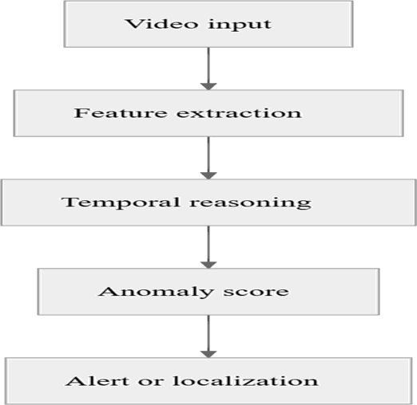

Fig 1: Flow Work
*Frame-level classification, video segmentation, and real-time inference trade-offs
A persistent design question in real-time surveillance is whether to classify individual frames, segment videos into clips, or infer anomalies over longer temporal windows. Frame-level systems are computationally simpler and can support immediate alarm logic, as shown by models that assess surveillance footage frame by frame and raise alarms when deviation from normality is detected (Nithesh et al., 2022). Yet frame-level inference may be vulnerable to transient noise or isolated motion cues that do not correspond to meaningful events, especially in crowded scenes (Rezaee et al., 2021), (Sofia Nishath & P.S., 2025). Video segmentation partly addresses this issue by grouping consecutive frames into analyzable units, as seen in DenseNet-based systems that process minute-long segments before issuing notifications (2025).
The literature also indicates that segment-based designs are frequently paired with alerting and storage logic. Some systems discard normal footage and retain only anomalous clips, a strategy that reduces storage load while concentrating attention on relevant episodes (2025). Others integrate detection with direct notification channels such as email, SMS, or sound alerts (K H, 2025), (MRS.B.SURIYA et al., 2025). The trade-off is clear: shorter inference windows improve responsiveness, but longer segments may improve contextual reliability and reduce false alarms. Hence, the practical challenge is to select the temporal granularity that best matches the target hazard, the camera environment, and the latency budget (J. Anvar Shathik, 2025), (Elmetwally et al., 2024).

*Crowd Density Estimation, Localization, and Behavior Classification in Dense Urban Scenes

Joint crowd density estimation and anomaly localization frameworks
Crowd density estimation has emerged as a useful precursor to anomaly detection because density influences both visibility and the interpretation of movement patterns. A recent joint framework combines crowd density classification with anomaly detection and localization in a single pipeline, using pre-processing, a density classifier, and a localization-focused anomaly module (Chaudhary et al., 2025). This kind of design is important because sparse, medium, and dense scenes present different visibility conditions and different normal behavior baselines. The framework therefore treats density not as a side variable but as a contextual input that shapes downstream interpretation (Chaudhary et al., 2025). Such a relationship strengthens the analytical case for multi-stage surveillance pipelines in which scene understanding precedes anomaly decision-making.
Theoretical value lies in the fact that density acts as a mediating construct between appearance and behavior. In dense scenes, the same motion may have different implications depending on occlusion and crowding, making direct anomaly inference less stable (Rezaee et al., 2021), (Sofia Nishath & P.S., 2025). By explicitly classifying density before anomaly localization, the IADL-CDE framework suggests a practical way to reduce ambiguity in scene interpretation (Chaudhary et al., 2025). More broadly, this line of work supports the view that public-safety monitoring should be context-sensitive rather than uniformly applied across all camera feeds.

*Crowded-scene classification under occlusion and complexity
Occlusion remains one of the most cited obstacles in crowded- scene monitoring. The survey literature emphasizes that anomalous behavior detection must contend with overlapping bodies, partial visibility, and motion clutter, all of which complicate tracking and feature extraction (Rezaee et al., 2021). Deep learning methods are often preferred because they outperform handcrafted-feature approaches under such conditions, though performance still depends on how well the model generalizes across crowd structures and lighting conditions (Rezaee et al., 2021). This is reflected in approaches that combine CNNs, LSTMs, or hybrid detectors to manage spatiotemporal complexity in crowded environments (Sofia Nishath & P.S., 2025), (J. Anvar Shathik, 2025).
The practical implication is that crowded-scene classification is best understood as an uncertainty management problem. A model must infer whether a scene is simply dense or genuinely hazardous, and that distinction is often blurred by temporary gatherings, rapid pedestrian flow, or occluded action (Chaudhary et al., 2025), (Rezaee et al., 2021). Systems that integrate preprocessing or density estimation may therefore be more stable than single-stage classifiers because they reduce the search space for later anomaly reasoning (Chaudhary et al., 2025). This is especially important for public spaces such as stations, sidewalks, and event venues, where the cost of misclassification can include unnecessary alerts or missed interventions (Filipponi et al., 2010), (Deng & Chen, 2023).

*Multi-class abnormal event recognition in public spaces
Beyond binary anomaly detection, several studies move toward multi-class recognition of abnormal events. C3D-plus-RNN models have been used to classify a set of distinct surveillance anomalies, including abuse, arson, and assault, demonstrating that richer taxonomies are feasible in real-time settings (Varshney, 2026). DenseNet-based systems similarly target a broad event set that includes fighting, burglary, shoplifting, robbery, explosion, shooting, and stealing (2025). These efforts matter because public safety operations often require not just the detection of abnormality, but an initial estimate of event type to guide dispatch and escalation.
Yet multi-class recognition is also more brittle than binary detection because classes may overlap visually and temporally. Violence, for example, may appear similar to crowd jostling unless temporal cues are sufficiently modeled (Kumar et al., 2024), (K H, 2025). Likewise, vehicle intrusions on sidewalks or pedestrian zones may require both object-level and scene-level interpretation to distinguish hazard from normal activity (Deng & Chen, 2023), (Dharany & Trinita, 2023). The literature therefore suggests that multi-class recognition is most effective when coupled with tracking, localization, and context-aware alert logic rather than treated as a standalone classification problem (Chaudhary et al., 2025), (MRS.B.SURIYA et al., 2025).

*YOLO-based detection of vehicles, pedestrians, violence, and hazardous objects
Object detection occupies a central position in urban hazard monitoring because many public risks are embodied in identifiable entities rather than abstract motion patterns. YOLO- based models have been used to detect violent objects such as baseball bats, knives, and pistols, while also supporting
downstream action recognition and emergency alerting (Kumar et al., 2024). Other studies apply YOLO to anomaly detection in live video more broadly, including the identification of sudden collisions or abnormal vehicle movements (MRS.B.SURIYA et al., 2025). In sidewalk hazard monitoring, YOLOv3 has been paired with instance segmentation to detect illegal vehicles intruding into pedestrian areas (Deng & Chen, 2023). These studies collectively show that object detection can transform surveillance from passive observation into event-specific hazard recognition.
The practical significance of YOLO lies in its suitability for real- time deployment. Because urban safety systems often need rapid inference, object detectors are attractive when they can localize people, vehicles, or hazardous items with sufficient speed to support alerting (Dharany & Trinita, 2023), (Deng & Chen, 2023). In violence detection, the detector is often only one component in a broader pipeline that also includes pose estimation or action classification, suggesting that object detection is necessary but not sufficient for understanding intent (Kumar et al., 2024). The literature therefore points toward hybrid systems in which objects provide the first layer of evidence and temporal or contextual models refine the final hazard decision.

*Multi-object tracking, segmentation, and localization in real time
Detection alone does not resolve the operational problem of follow-up monitoring, which is why several studies add tracking or segmentation. Deep SORT has been used to preserve identities after YOLOv4 detection in crowded anomaly settings, indicating that tracking can help maintain continuity across frames and reduce ambiguity when multiple people or objects overlap (Sofia Nishath & P.S., 2025). Similarly, YOLACT++ has been combined with YOLOv3 for sidewalk monitoring, where segmentation first isolates the relevant roadway or pedestrian zone before object detection identifies intruding vehicles (Deng & Chen, 2023). This sequential structure is important because localization clarifies not only what is present, but where a hazard is occurring.
Localization also appears in systems designed for anomaly detection and alerting. The incremental spatiotemporal learner was developed for anomaly detection and localization in real-time surveillance, highlighting that localization is not an optional add- on but a core function when a camera operator or emergency responder must act on the detected event (Nawaratne et al., 2020). Likewise, the crowd-density framework couples anomaly detection with localization after density classification, suggesting that hazard position and scene context should be estimated jointly (Chaudhary et al., 2025). These approaches imply a shift from classification-centric surveillance toward spatially actionable intelligence.

*Edge computing, FPS constraints, and deployment in smart city infrastructures
Deployment constraints strongly shape which urban hazard models are practical. Some systems explicitly target edge devices and local processing to preserve privacy and reduce dependence on cloud infrastructure, as in the ConvLSTM-based smart vision system (J. Anvar Shathik, 2025). Others describe an ensemble of the full model and an edge device for real-time testing, again indicating that edge execution is central to operational feasibility (Kumar et al., 2024). In smart-city settings, this matters because persistent low-latency performance may be more important than

marginal gains in offline accuracy (Filipponi et al., 2010), (J. Anvar Shathik, 2025).

*Multi-Modal, Non-Visual, and Event-Driven Approaches to Public Hazard Detection

Heterogeneous sensors and event-driven smart city architectures

Visual surveillance alone is not the only route to public hazard detection. An event-driven smart-city architecture has been proposed to manage heterogeneous sensors in public spaces, with a subway testbed demonstrating how cooperation among sensor types can improve anomalous event detection and emergency communication (Filipponi et al., 2010). This approach is important because public hazards may generate detectable signals beyond the camera domain, and sensor fusion can improve situational awareness when visual fields are obstructed or unavailable. Event-driven design also encourages modularity, allowing systems to react to context changes rather than continuously processing every stream at maximal intensity (Filipponi et al., 2010).
Theoretical significance follows from the fact that event-driven architectures represent a shift from passive sensing to coordinated urban awareness. They suggest that surveillance systems can be organized around triggers, thresholds, and cross- sensor communication rather than isolated video clips (Filipponi et al., 2010). In practice, such architectures may be especially useful in transportation hubs or underground environments where cameras are only one component of the safety stack. The literature therefore supports an expanded model of urban monitoring in which visual AI is integrated into broader sensing ecosystems (Filipponi et al., 2010), (Dharany & Trinita, 2023).

Non-visual crowd sensing and multi-sensory anomaly cues

Non-visual sensing has also been used directly for crowd anomaly detection. A multi-sensory method based on mobile phone data extracted statistical features from sliding time windows and used Random Forest classification to detect unusual crowd behavior (Irfan et al., 2018). The authors argue that mobile data can serve as an alternative to video sensors and report significant performance on datasets collected during social event gatherings (Irfan et al., 2018). This matters because non- visual cues may be available in settings where video is impractical, intrusive, or incomplete.
The value of non-visual sensing lies in complementarity rather than replacement. Mobile or sensor-derived signals may capture movement patterns, crowd disruptions, or collective shifts that are difficult to infer from image data alone (Irfan et al., 2018). At the same time, the approach depends on robust feature extraction and appropriate deployment conditions, and the abstract does not establish that it can fully substitute for video-based monitoring across all urban contexts (Irfan et al., 2018). Accordingly, the literature suggests that multi-sensory anomaly cues are best understood as an additional evidentiary layer, particularly for privacy-sensitive or visually constrained environments.

*Privacy-preserving and context-aware monitoring in mixed- use public spaces
Privacy is increasingly presented as a design requirement rather than a downstream compliance issue. A privacy-preserving framework for mixed-use environments proposes adaptive protection based on situational context, using non-biometric tracking, context-aware model switching, and policy observability (Akangsha Sunil Bedmutha, 2025). The case study suggests that such a framework can mediate privacy during contextual transitions, including emergencies, while still supporting functions such as cross-camera tracking and behavior analysis (Akangsha Sunil Bedmutha, 2025). This is a notable development because it reframes urban monitoring as a context-governed process rather than a uniformly intrusive one.

*System Performance, Operational Constraints, and Implementation Considerations

Accuracy, precision, recall, F1-score, AUC, and mAP across reported systems
Across the reviewed literature, performance is reported using a heterogeneous set of metrics that reflect different model objectives. Some studies emphasize classification accuracy, such as the DenseNet-based system for surveillance segments and the CNN-LSTM-YOLOv4 approach for crowded anomaly detection (2025), (Sofia Nishath & P.S., 2025). Others report AUC, as in the I3D-ResNet50 plus MIL framework, which achieved 82.85% AUC on surveillance video (Elmetwally et al., 2024). Object- detection studies often rely on mAP, including the violence- detection system with YOLOv7 that reported 89.5% mAP and the sidewalk segmentation pipeline that measured YOLOv3 accuracy and YOLACT++ mAP (Kumar et al., 2024), (Deng & Chen, 2023). The crowd-density framework also reports improvements in accuracy, precision, recall, F1-score, and Cohen’s Kappa, indicating that multi-metric reporting is becoming common in this area (Chaudhary et al., 2025).
This diversity of metrics is informative but complicates direct comparison. High accuracy in one setting does not necessarily mean operational superiority in another, particularly when class imbalance, detection granularity, and localization requirements differ (Varshney, 2026), (Rezaee et al., 2021). The literature therefore suggests that public-safety evaluation should be multi- dimensional, combining classification with alert usefulness and spatial specificity. In practical terms, a system with strong mAP but poor temporal reasoning may be less useful than one with moderate accuracy but reliable event persistence under crowded conditions (Kumar et al., 2024), (Sofia Nishath & P.S., 2025).
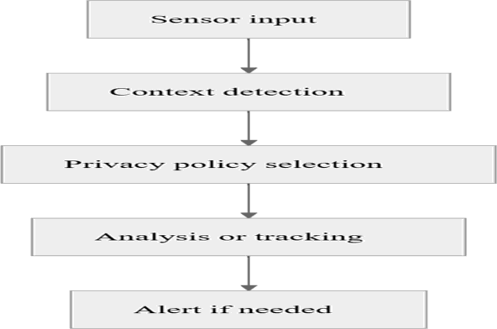
Fig 2: System Process

*Latency, throughput, dataset dependence, and generalization limits
Operational constraints are a recurring limitation across the field. Several studies explicitly note the need for real-time processing and report FPS or inference speed as evidence of feasibility (Deng & Chen, 2023), (J. Anvar Shathik, 2025). Others emphasize that systems are trained and tested on benchmark datasets or platform-specific datasets, which may not fully reflect the diversity of real urban scenes (Elmetwally et al., 2024), (Chaudhary et al., 2025), (J. Anvar Shathik, 2025). The survey of crowd anomaly detection also highlights generalizability, computational complexity, and execution time as persistent concerns in crowded environments (Rezaee et al., 2021).
Dataset dependence is particularly important because surveillance models can learn normality that is too narrowly defined. The incremental spatiotemporal learner was proposed in part because prior methods depended heavily on known normality training data and on reconstruction error, both of which can struggle when normal behavior evolves over time (Nawaratne et al., 2020). This critique remains relevant across the literature: systems may perform well on benchmark video but degrade when confronted with new camera angles, crowd compositions, or hazard types (Nawaratne et al., 2020), (Akangsha Sunil Bedmutha, 2025). Generalization, therefore, is not merely a statistical issue but a public-safety concern, because false negatives in unfamiliar settings can undermine trust in automated monitoring.

Our Method:
In our method, shown in Figure 1, we first decompose the input videos into clips of 16 frames with 1 frame over- lap, and resize them to the fixed width of 320 pixels. A proportion of the clips containing normal crowd behaviors are selected as the training set, and all clips are viewed as the testing set.
We then extract dense trajectories using the code pro- vided by [29, 30]. We make several modifications to their code in order to adapt dense trajectories to the anomaly de-tection task. First, we output sequences of point coordinates rather than the normalized trajectory descriptors to retain the location and magnitude information. Second, we lowe r the threshold for rejecting stationary trajectories from 3 to 0.5 to avoid losing subtle motion information. Third, we only use the trajectories at the original spatial scale so all trajectories are comparable in terms of magnitude. Along with dense trajectories, we also calculate trajectory-aligned
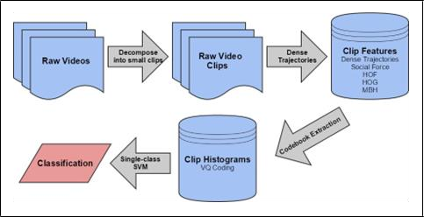
Fig. 3. Flow and structure of crowd anomaly detection.
As each video clip contains 16 frames, we can compute a
sequence of 14 interaction forces for each trajectory in the clip. Note that the video clips normally consist of differ-ent numbers of trajectories. Therefore, we adopt a bag-of-words approach. We run K-means clustering on all of the interaction force sequences in the training clips to build a codebook of vocabulary size C = 1024.

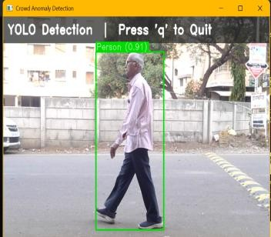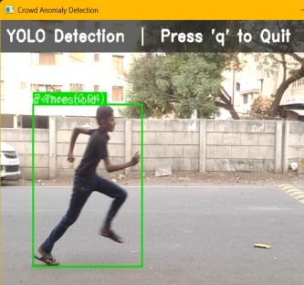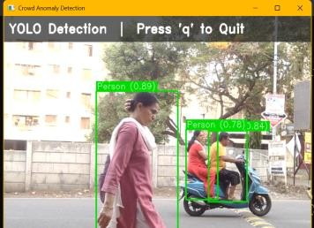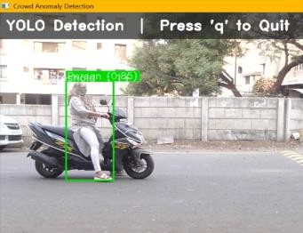
.
Figure 4. Visualization of the magnitude of the computed interac-tion forces overlaid over two video frames. The underlying frames in the left and right image are from video clips containing normal and abnormal crowd behaviors respectively.

5. Experiments and Discussion:
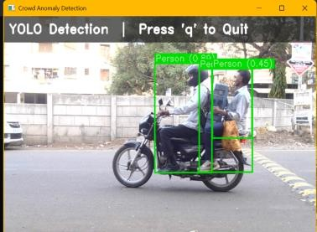
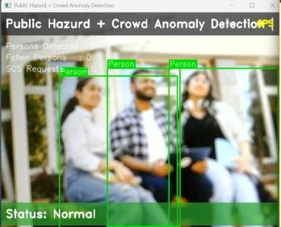
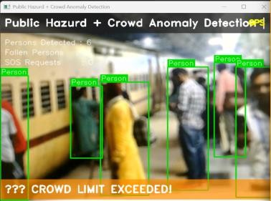
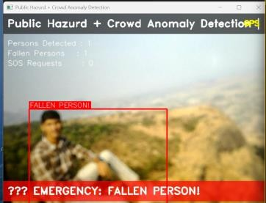
where vc is the average velocity of the particle’s K nearest neighbors. In our experiments, we choose K = 5. Figure 2 shows the visualization of the magnitude of the computed interaction forces overlaid over two video frames.

Figure 5. Crowd Detetion & Man Fallen

- shows the means and standard deviations of areas under the ROC curves. These are calculated by averaging the area under

the ROC curve for each individual trial.
The results from our trials show the social force feature is the most effective feature for detecting anomalous events with an average area under the ROC curve of 0.97428. In- terestingly, dense trajectories alone are quite accurate; for a false detection rate of less than about 2.5% the dense trajec- tories slightly outperform social force. The results for HOF, HOG and MBH features are un-derwhelming with areas of 0.68989, 0.64747, and 0.49221, respectively.

Evaluation of kernels
In we investigate if it is possible to achieve performance gains by using a different kernel to train our single-class SVM. Potential kernel candidates are a polyno-mial kernel and a radial basis kernel. For the polynomial kernel we tested the function k (x, y) = γ xT y + C d with parameters C = 0, d = 3, γ = 1 , where N is the number of training features. For the radial basis kernel we tested the function k (x, y) = e(−γ|x−y|2 ) with γ = 1 , where N is the number of training features. To test these
kernels we used the same data from the 5 random trials in the evaluation of features, but changed the kernel for the SVM. The average area under the ROC curves is shown
- 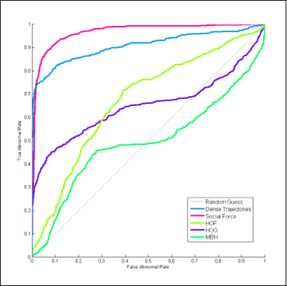
Figure 6. Aggregate ROC curves
Our results indicate that for dense trajectories and social force the top performing kernel is the linear kernel. How-ever, for HOF, HOG, and MBH features the radial basis kernel drastically improves the performance of the SVM, even exceeding the linear kernel. This is probably explained by more complex decision boundaries for the HOG, HOF, and MBH features compared to dense trajectories and social force. Despite this large performance gain, neither HOF, HOG, or MBH using the radial basis kernel performs better than dense trajectories or social force using a linear kernel.

UMN dataset
The University of Minnesota (UMN) unusual crowd ac- tivity dataset [1] contains 11 videos of 3 different indoor and outdoor scenes. Each video consists of an initial part of normal behaviors and ends with abnormal behaviors of escaping.
The ROC curves in Figure 6 illustrate that our method outperforms the state-of-the-art method in [22] in detecting
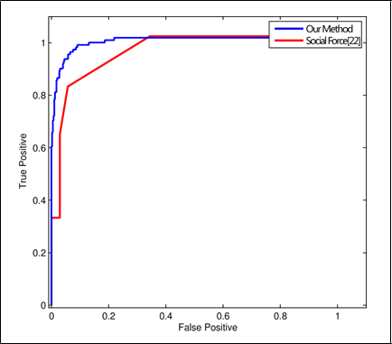
Figure 8. ROC

curves for detection of abnormal behaviors in the UMN dataset. Our method (blue) outperforms the state-of-the-art method (red).

Method | Area under ROC
Our Method | 0.98
Social Force [22] | 0.96
Table 1. Comparison of the use of our method versus the state-of- the-art method for detection of the abnormal behaviors in the UMN dataset.

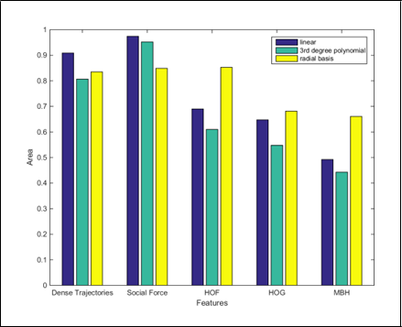
.

Figure 7. Average area under the ROC curves each feature using a linear, polynomial, and radial basis kernel.

Method | Area under ROC
Our Method | 0.96
Social Force [22] | 0.73

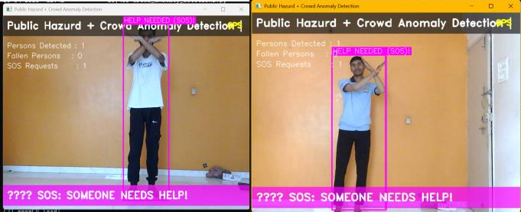
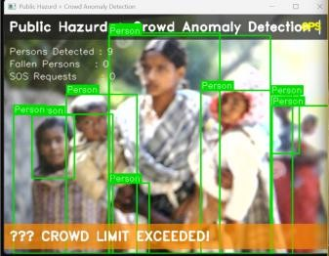
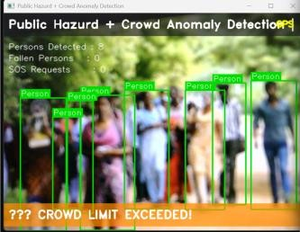
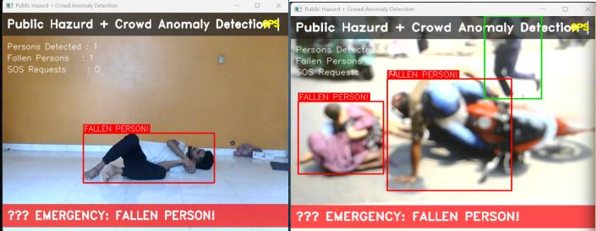
Figure 9. Qualitative results of detection

for four sample videos of the UMN dataset. Each row shows the results for a video in the dataset. The ground truth bar and the de-tection result bar indicate the actual and predicted labels of each frame. Green color represents the normal frames, while red rep-resents the abnormal ones. In each row, the left image shows the first frame of the video, and the right image shows a detected ab-normal frame. The black triangle on the horizontal bars identify the timing of the shown abnormal frames.

UCF web dataset
The University of Central Florida (UCF) web dataset [2] contains more challenging videos of real-world crowds that have been collected from various online sources. It contains 20 videos which are divided into 12 normal crowd scenes such as pedestrian walking and marathon running, and 8 abnormal scenes of escape panics, protesters clashing and crowd fighting.
In order to compare our performance with [22], we fol- low the same evaluation procedure as theirs. We randomly exclude 2 videos from the normal set and train on the rest. In the testing phase we add the excluded videos to the test set. We run this experiment 10 times and plot the ROC curve by averaging the results of these experiments. Based on our findings, we use the social force feature alone com-bined with a linear kernel.
The ROC curves in Figure 8 illustrate that our method outperforms the state-of-the-art method in [22] in detecting anomalous events, and Table 3 provides the quantitative re-sults of the comparison. If a false detection rate of less than 2.5% is allowed, the true detection rate is 66.15%, and the overall detection accuracy is 88.22%.
Table 2. The comparison of the use of our method and the state- of-the-art method for detection of the abnormal behaviors in the UCF web dataset.

These models receive either supervised or unsupervised training. In order to take the necessary action, such as dispersing the crowd, when the crowd density exceeds a predetermined threshold, the degree of congestion can be calculated. The objects are tracked, and the anomaly is analyzed by utilizing the objects under tracking and their behavior. A final decision can be made in real-time whether the crowd state is normal or abnormal.
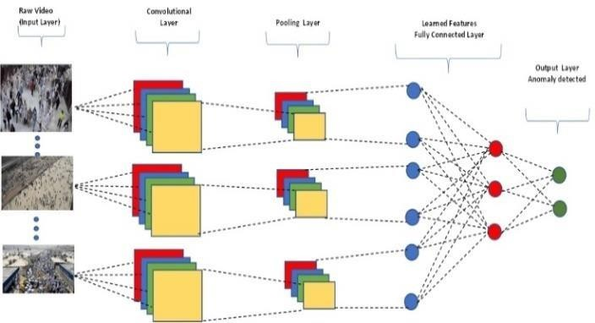
Fig. 10. A deep learning model for the automatic feature extraction from crowd scenes for crowd anomaly detection.

The research on crowd anomaly detection can be categorized into two types based on the availability of labels and the type of anomalies. The different types of crowd anomaly detection methods and related works on them are given in the following subsections.
A. CAD based on the Availability of Labels
Based on the availability of labels, the models used for crowd anomaly detection are divided into supervised/semi- supervised, unsupervised, hybrid, and one-class neural networks, as shown in Fig. 4. Supervised learning: This type of anomaly detection relies on labelled data, where the anomalies and normal behavior are defined beforehand. The model is trained on this labelled data, which can then be used to detect anomalies in new, unseen data [15], [16]. Semi- supervised learning: This type of anomaly detection also relies on labelled data, but it also uses unlabeled data to enhance the model's performance. The model is trained on labelled and unlabeled data, which can then be used to detect anomalies in new, unseen data. Unsupervised learning: This type of anomaly detection does not rely on labelled data.

Challenges and Limitations
In crowd scenarios with a variety of conditions, a reliable crowd anomaly detection algorithm tries to evaluate both local and global density and reliably anticipate crowd behaviour. The model's performance is significantly impacted by the changing circumstances. Therefore, it's crucial to first comprehend these

difficulties and how they could affect the performance of the model. The development of more reliable models is aided by a thorough grasp of these difficulties.
- Difficult to monitor crowd behaviour in various settings. For instance, it is significantly simpler to count and track the individuals in images captured by a single CCTV camera (such as those in the Mall dataset [2]) than to count people in images captured by numerous security cameras (such as those in the WorldExpo'10 dataset [5]).
- The distribution of objects in crowd photos may vary in different scenarios. For example, seats in a sports arena are evenly distributed among people, with constant spacing between objects, whereas in crowded streets, things might be distributed at random. In the absence of other features that would alter the accuracy, uniformly dispersed crowds can be estimated more precisely than non-uniform crowds.
- Due to the different lighting conditions, the illumination in an image can change during the day and in various areas of the same image. This makes learning difficult because the same object (like people) in the same image will have varying pixel values. Other conditions which make CAD difficult include changes in the weather, noise and pixelation in images, rotation of objects, etc.

Summary
This review paper provides an in-depth analysis of crowd anomaly detection and its importance in real-world surveillance and security. The latest research on crowd analysis is reviewed and summarized, with a focus on the major components of crowd anomaly detection, such as crowd density estimation, object tracking, and object behavior analysis. The paper also provides a summary of research based on different taxonomies, including the type of anomaly, and the type of dataset labels of the anomaly. Publicly available datasets used for crowd analysis were also reviewed, including the types of anomalies they address. Considerations for evaluating model performance and current challenges in the field were also discussed. In light of the review, the paper provides directions for future research, including the need for model generalization for different anomalies in different scenarios, designing application-specific crowd anomaly detection s, and effectively selecting the most appropriate models for analysis to reduce unnecessary resource usage and carbon emissions.

Future Directions
Some of the research directions based on the challenges identified by the various researches are mentioned next. The same benchmark datasets are used to train and evaluate the majority of crowd counting methods. So, model generalization hasn't been studied much, or studies are limited to the models that were fine-tuned on one dataset after being pretrained on another. However, the results that are normally published come from the refined model. This causes a significant disparity in the generalization of crowd counting models across different scenes, which warrants more research. It would be fascinating to observe model generalization in a variety of unusual situations, such as
interior and outdoor videos, CCTV photos, drone photographs, etc.
An effective model must be able to run on a variety of hardware platforms with diverse computational capabilities, including servers, drones, cameras, mobile phones, etc., in order to support the potential applications of crowd anomaly detection. Applications (such as real-time or non-real-time), types of surveillance (such as CCTV-based surveillance or drone-based surveillance), and scenarios (shopping malls, metro stations, stadiums, etc.) all have different performance requirements.

Conclusion:

Synthesis, Public-Safety Implications, and Research Directions
The literature reviewed here indicates that real-time public hazard detection is most effective when detection, localization, and alerting are treated as a connected pipeline rather than separate tasks. Deep models based on CNNs, I3D, DenseNet, LSTM, and ConvLSTM support anomaly reasoning over frames or clips (Ananthakrishnan et al., 2022), (Elmetwally et al., 2024), (J. Anvar Shathik, 2025), while object-detection and tracking systems improve hazard specificity by identifying vehicles, weapons, or abnormal motion trajectories (Kumar et al., 2024), (Deng & Chen, 2023), (Sofia Nishath & P.S., 2025). Meanwhile, crowd-density frameworks and incremental spatiotemporal learning approaches demonstrate that context-aware localization can improve robustness when scenes are dense or behaviors evolve over time (Chaudhary et al., 2025), (Nawaratne et al., 2020). Across these designs, alerting mechanisms remain central because the practical value of detection depends on whether the system can trigger an actionable response (K H, 2025), (MRS.B.SURIYA et al., 2025).

*Implications for smart cities, emergency response, and operational deployment
For smart cities, the implication is that surveillance systems should be embedded in broader response ecosystems rather than deployed as isolated classifiers. Event-driven architectures show how heterogeneous sensors can support emergency communication in public spaces (Filipponi et al., 2010), while edge-based deployments reduce latency and preserve local processing capability (J. Anvar Shathik, 2025), (Kumar et al., 2024). Systems that can detect violence, accidents, sidewalk intrusions, or abnormal crowd movement may shorten response times and improve situational awareness if they are integrated with operational protocols for dispatch and notification (K H, 2025), (MRS.B.SURIYA et al., 2025). The challenge is to sustain accuracy without sacrificing privacy, throughput, or public trust.

*Future research needs in robustness, privacy, and multimodal integration
Future work should prioritize robustness to evolving normality, because several studies imply that static notions of normal behavior are insufficient in dynamic public environments (Nawaratne et al., 2020), (Rezaee et al., 2021). It should also deepen privacy-preserving design, especially in mixed-use settings where surveillance must adapt to contextual boundaries and governance requirements (Akangsha Sunil Bedmutha, 2025). Finally, multimodal integration deserves greater emphasis, since non-visual sensing, visual analytics, and event-driven architectures each capture different aspects of public risk (Irfan et al., 2018), (Filipponi et al., 2010).

REFERENCE

- Akangsha Sunil Bedmutha. (2025). Cross-Contextual Vision: Architecting Privacy-Preserving Multi-Modal AI Systems for Public Safety and Retail in Mixed Spaces. In Journal of Computer Science and Technology Studies (Vol. 7, Issue 9, pp. 63–70). Al- Kindi Center for Research and Development. https://doi.org/10.32996/jcsts.2025.7.9.8
- Ananthakrishnan, B., Padmaja, V., Nayagi, S., & M, V. (2022). Deep Neural Network based Anomaly Detection for Real Time Video Surveillance. In International Journal on Recent and Innovation Trends in Computing and Communication (Vol. 10, Issue 4, pp. 54–64). Auricle Technologies, Pvt., Ltd. https://doi.org/10.17762/ijritcc.v10i4.5534
- Chaudhary, D., Kumar, S., & Singh Dhaka, V. (2025). Intelligent Anomaly Detection and Localization With Crowd Density Estimation for Improved Public Safety. In IEEE Access (Vol. 13, pp. 169912–169928). Institute of Electrical and Electronics Engineers (IEEE). https://doi.org/10.1109/access.2025.3614146
- Deng, Y., & Chen, F. (2023). Real-time Sidewalk Anomaly Detection from Surveillance Video with A Combination Model. In 2023 12th International Conference on Computing and Pattern Recognition (pp. 229–234). ACM.
https://doi.org/10.1145/3633637.3633673
- Dharany, K., & Trinita, M. (2023). Enhancing Urban Safety: The Role of Object Detection in Smart City Surveillance Systems. In ITEJ (Information Technology Engineering Journals) (Vol. 8, Issue 2, pp. 63–72). IAIN Syekh Nurjati Cirebon. https://doi.org/10.24235/itej.v8i2.122
- Elmetwally, A., Eldeeb, R., & Elmougy, S. (2024). Deep learning based anomaly detection in real-time video. In Multimedia Tools and Applications. Springer Science and Business Media LLC. https://doi.org/10.1007/s11042-024-19116-9
- Filipponi, L., Vitaletti, A., Landi, G., Memeo, V., Laura, G., & Pucci, P. (2010). Smart City: An Event Driven Architecture for Monitoring Public Spaces with Heterogeneous Sensors. In 2010 Fourth International Conference on Sensor Technologies and Applications (pp. 281–286). IEEE.
https://doi.org/10.1109/sensorcomm.2010.50
- Irfan, M., Tokarchuk, L., Marcenaro, L., & Regazzoni,
C. (2018). ANOMALY DETECTION IN CROWDS USING MULTI SENSORY INFORMATION. In 2018
15th IEEE International Conference on Advanced Video and Signal Based Surveillance (AVSS) (pp. 1–6). IEEE. https://doi.org/10.1109/avss.2018.8639151
- J. Anvar Shathik. (2025). SMART VISION SYSTEMS FOR PUBLIC SAFETY: REAL-TIME CROWD MONITORING AND ANOMALY DETECTION IN URBAN SPACES USING DEEP LEARNING AND
EDGE COMPUTING. In International Journal of Applied Mathematics (Vol. 38, Issue 6s, pp. 720–743). Academic Publications.
https://doi.org/10.12732/ijam.v38i6s.430
- K H, V. (2025). AI-Driven Real-Time Surveillance: Anomaly Detection and Notification System. In INTERNATIONAL JOURNAL OF SCIENTIFIC
RESEARCH IN ENGINEERING AND MANAGEMENT
(Vol. 09, Issue 05, pp. 1–9). Edtech Publishers (OPC)
Private Limited. https://doi.org/10.55041/ijsrem47628
- Kumar, P., Shih, G.-L., Guo, B.-L., Nagi, S. K., Manie,
Y. C., Yao, C.-K., Arockiyadoss, M. A., & Peng, P.-C. (2024). Enhancing Smart City Safety and Utilizing AI Expert Systems for Violence Detection. In Future Internet (Vol. 16, Issue 2, p. 50). MDPI AG. https://doi.org/10.3390/fi16020050
- MRS.B.SURIYA, R, D. B., R, J., T, J., & V, H. (2025).
Computer Vision-Based Accident Detection and Alert System. Zenodo (CERN European Organization for Nuclear Research).
https://doi.org/10.5281/zenodo.16601564
- Nawaratne, R., Alahakoon, D., De Silva, D., & Yu, X. (2020). Spatiotemporal Anomaly Detection Using Deep Learning for Real-Time Video Surveillance. In IEEE Transactions on Industrial Informatics (Vol. 16, Issue 1, pp. 393–402). Institute of Electrical and Electronics Engineers (IEEE).
https://doi.org/10.1109/tii.2019.2938527
- Nithesh, K., Tabassum, N., Geetha, D. D., & Kumari, R.
D. A. (2022). Anomaly Detection in Surveillance Videos Using Deep Learning. In 2022 International Conference on Knowledge Engineering and Communication Systems (ICKES) (pp. 1–6). IEEE.
https://doi.org/10.1109/ickecs56523.2022.10059844
- Rezaee, K., Rezakhani, S. M., Khosravi, M. R., & Moghimi, M. K. (2021). A survey on deep learning-based real-time crowd anomaly detection for secure distributed video surveillance. In Personal and Ubiquitous Computing (Vol. 28, Issue 1, pp. 135–151). Springer Science and Business Media LLC. https://doi.org/10.1007/s00779-021-01586-5
- S, S., & Lokesh, I. (2025). A Real-Time Anomaly Detection System for Video Surveillance Using DenseNet201. In International Journal of Innovative Research in Information Security (Vol. 11, Issue 02, pp. 145–152). AM Publications. https://doi.org/10.26562/ijiris.2025.v1102.13
- Sofia Nishath, & P.S., N. D. (2025). Video Anomaly Detection in Crowded Scenes Using Deep Learning. In Journal of Artificial Intelligence and Technology. Intelligence Science and Technology Press Inc. https://doi.org/10.37965/jait.2025.0775
- Varshney, D. (2026). Real-time Anomaly Detection and Multi-class Classification in Surveillance Videos Using Deep Learning. In Informatica (Vol. 50, Issue 6). Slovenian Association Informatika. https://doi.org/10.31449/inf.v50i6.8136

